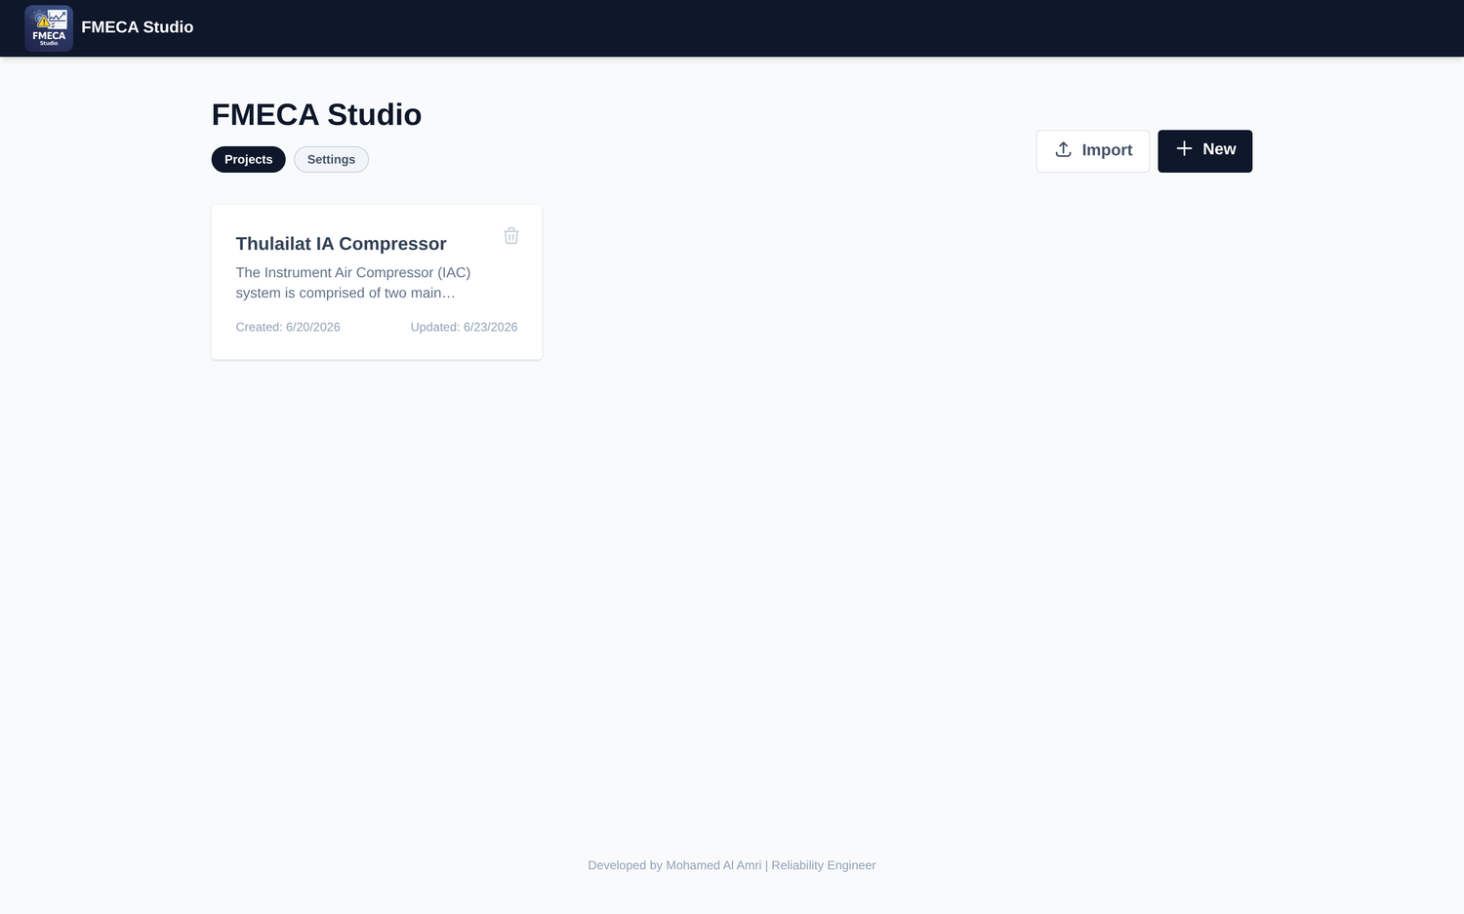
FMECA Studio
User Guide for Reliability Engineers
Building professional FMECA tables for RCM projects
Corporate (Cloudflare) Deployment • Microsoft Copilot via Power Automate
Worked example: Thulailat Instrument-Air Compressor Package

Contents
1. Introduction | 3
2. Getting started | 4
3. The Dashboard | 6
4. Building a FMECA step by step | 7
5. AI-assisted features | 12
6. Views and the toolbar | 15
7. Exporting and sharing | 18
8. Best practice for a professional FMECA | 19

1. Introduction
FMECA Studio is a browser-based workbench for building Failure Mode, Effects and Criticality Analysis (FMECA) worksheets as part of a Reliability-Centered Maintenance (RCM) program. It guides you from a blank project to a complete, exportable FMECA table, and uses an AI assistant to accelerate the repetitive drafting work while keeping the reliability engineer firmly in control of every judgement.
The application is fully self-contained: your projects are stored locally in your browser, and analytical content is generated on demand through your organization’s approved AI channel. There is no separate database to install and nothing leaves your machine except the specific prompts you choose to send to the AI service.

1.1 Who this guide is for
This guide is written for reliability, maintenance and integrity engineers who are responsible for producing FMECA / FMEA worksheets, criticality assessments and maintenance task selections. It assumes you understand the reliability concepts (functions, functional failures, failure modes, effects, causes and RPN) but not the tool. Every feature is illustrated with the Thulailat Instrument-Air (IA) Compressor Package example project.

1.2 How FMECA Studio structures an analysis
The tool follows the classic RCM decomposition. Understanding this hierarchy is the single most important thing before you start — every screen in the application is organised around it.
Level | Meaning | Thulailat example
Project | The asset / package under analysis | Thulailat IA Compressor
Subsystem | A maintainable sub-assembly with its own specs & function | Screw Compressor; Lubrication Oil System
Function | What the subsystem must do, with performance standards | Compress air to instrument quality; deliver 600 SCFM at 10 barg
Functional Failure | A way the function is not delivered | Produces non-instrument-quality air
Failure Mode | The specific mechanism that causes the failure | Oil/air separator element saturation / breakthrough
Effect / Cause | Local & end consequences, and the root cause | Oil carry-over to dryer; element service-life exceeded
Controls & Mitigation | Existing controls and recommended actions (with owner) | Separator ΔP alarm; run-hour-based replacement
RPN | Severity × Occurrence × Detection risk score | S 5 × O 5 × D 2 = 50

Data model at a glance
Project → Subsystems → Functions → Functional Failures → Failure Modes → (Effect, Cause, Controls, Mitigation, RPN)

2. Getting started

2.1 Opening the application
FMECA Studio runs entirely in your web browser — there is nothing to install. Open the corporate deployment URL provided by your reliability team (the application is hosted on Cloudflare). It loads directly to the Dashboard shown in the next section. Because your work is saved in the browser’s local storage, always use the same browser profile on the same machine to return to your projects, and export a JSON backup regularly (Section 7).
Good to know
Projects auto-save continuously — the header shows a “• Auto-saved” indicator. There is no manual “Save” button. Clearing your browser data will delete unsaved projects, so keep JSON exports of anything important.

2.2 Connecting the AI provider (corporate Copilot)
Before the AI features will work you must point FMECA Studio at your organization’s AI channel. Open Settings from the Dashboard (the “Settings” pill under the title). In the corporate deployment the AI Provider panel deliberately exposes only the approved options — Copilot and OpenRouter — so that analysts cannot route company data through personal API keys.
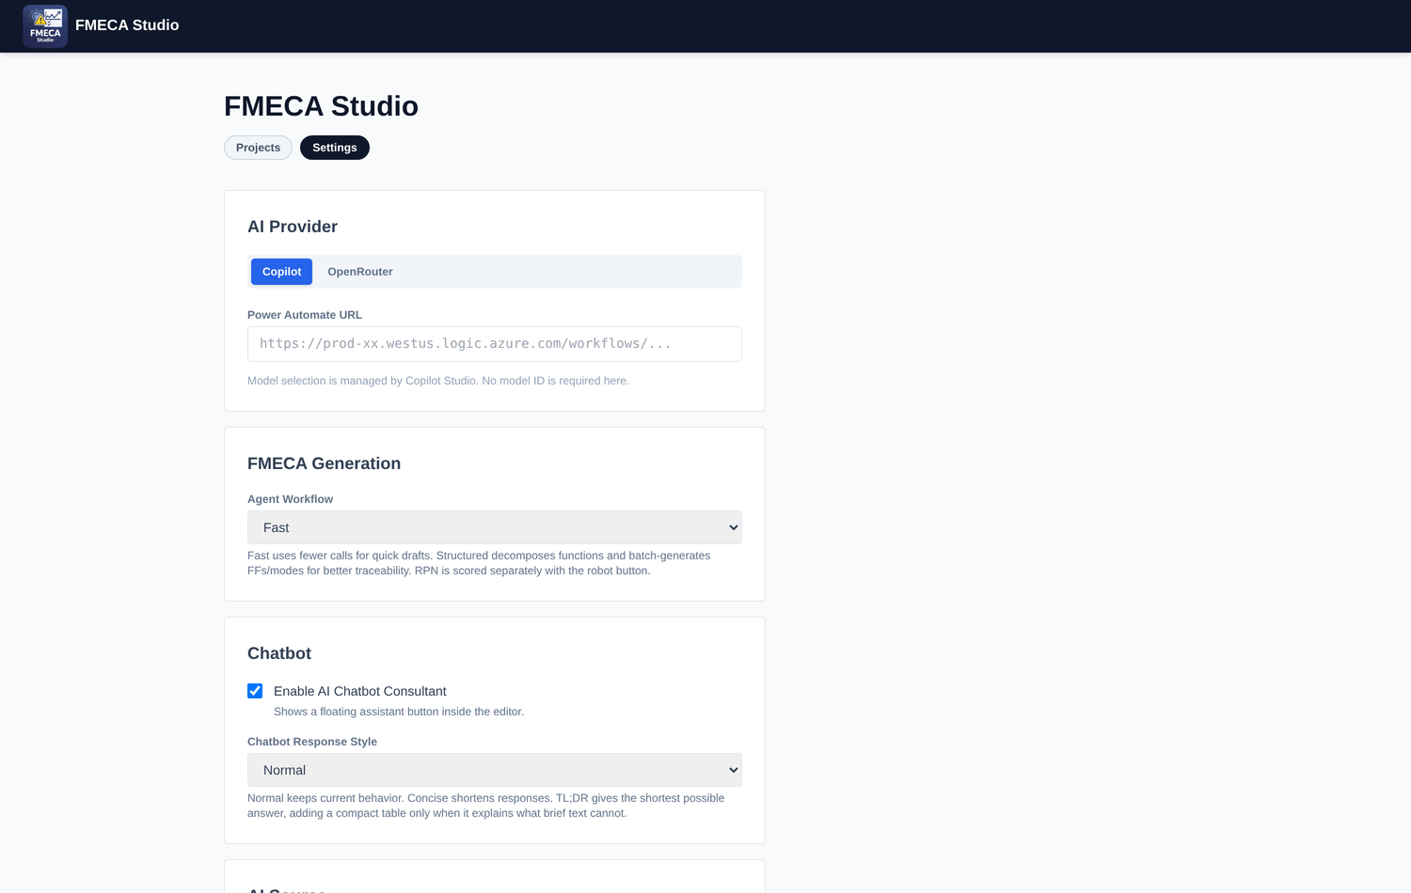
Figure 2.1 — The AI Provider panel in the corporate build. Only Copilot and OpenRouter are shown.
For corporate use, keep the provider on Copilot and paste your Power Automate URL into the field provided. This is the HTTP-trigger endpoint of the Power Automate flow that fronts your Microsoft Copilot Studio agent (it looks like https://prod-xx.…logic.azure.com/workflows/…). No API key and no model name are required — model selection is managed centrally by Copilot Studio.
Corporate policy
Company reliability data must only be processed through the approved Copilot channel. Do not switch the provider away from Copilot, and do not paste personal API keys. If the Power Automate URL is blank, all AI buttons (Auto-Fill, Generate, the RPN robot and the Copilot chat) will prompt you that the URL is required.

2.3 Other useful settings
Three further settings shape how the AI behaves. You can return to change them at any time.
- Agent Workflow (FMECA Generation). “Fast” uses fewer calls for quick drafts; “Structured” decomposes functions and batch-generates functional failures and modes for better traceability. RPN is always scored separately with the robot button.
- Chatbot. Enables the floating “FMECA Consultant” assistant inside the editor and sets its response style (Normal, Concise or TL;DR).
- AI Source. Chooses what context the AI draws on: “AI only” (general knowledge), “File only (RAG)” (a reference document you upload) or “Hybrid” (your project data plus the reference file). You can also load a Global Reference File and a Checklist Knowledge file (PM checklists by team and interval) that feed mitigation suggestions.

3. The Dashboard
The Dashboard is the home screen. It has two tabs — Projects and Settings. The Projects tab lists every analysis stored in your browser as a card showing its name, description and created / updated dates.

Figure 3.1 — The Projects dashboard with the Thulailat IA Compressor project.
From here you can:
- Create a new project — click New to start a blank analysis and open the editor.
- Import a project — click Import and select a previously exported FMECA JSON file (this is how you would open the Thulailat example file).
- Open a project — click anywhere on a project card to open it in the editor.
- Delete a project — use the trash icon on the card (this cannot be undone, so export first).

Starting from the example
To follow this guide hands-on, click Import and choose the file “FMECA_Thulailat IA Compressor.json”. The fully worked analysis will appear as a new card. Click it to explore every feature described below.

4. Building a FMECA step by step
This is the core workflow. Opening a project takes you to the Build view — a hierarchical editor where you expand the asset from the top down. The screenshot below shows the editor for the Thulailat Screw Compressor subsystem, with the project context, subsystem card, function, and the first functional failure and mode.
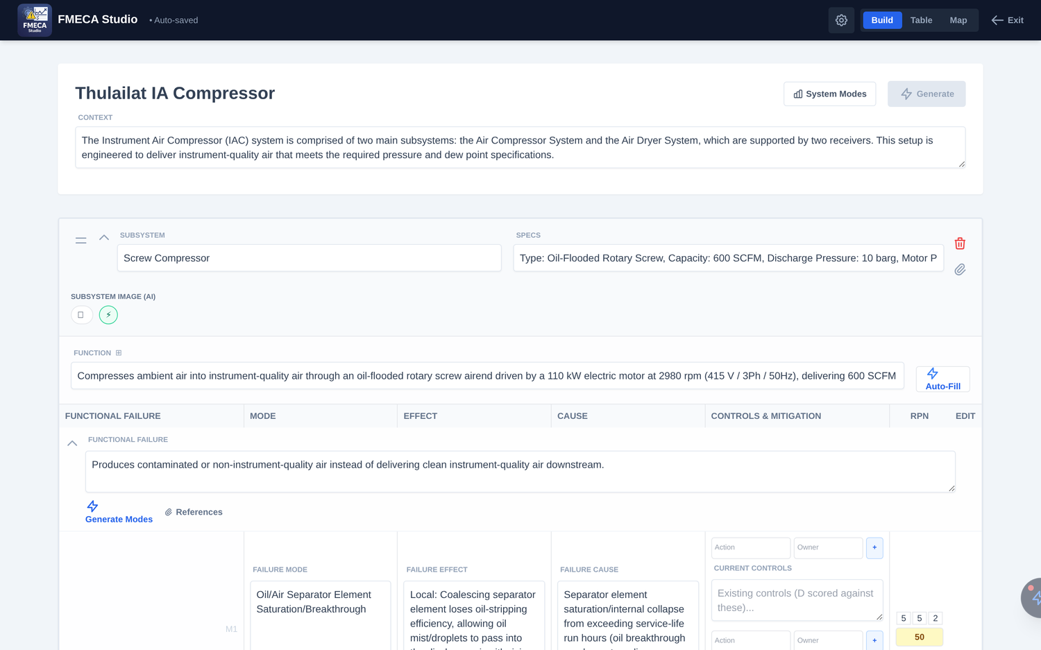
Figure 4.1 — The Build editor: project context, subsystem, function, functional failure and failure mode with RPN.

4.1 Define the project and context
At the top of the editor, give the project a clear name and write a short Context describing the asset and its operating envelope. In the example, the context explains that the IA package comprises an air-compressor system and an air-dryer system feeding two receivers to deliver instrument-quality air. This context is important: it is fed to the AI as background for every generation, so a good description improves every downstream suggestion.

4.2 Generating the FMECA with AI
FMECA Studio can draft the analysis for you at four levels of granularity — from the whole worksheet in one click down to a single field. You choose how much to automate; every result is fully editable afterwards. The four generation tools are:
Tool | Where it is | What it produces
“Generate” (master) | Top-right of the editor, beside System Modes | The entire FMECA — subsystems, functions, functional failures and failure modes for the whole asset
“Auto-Fill” | Beside each subsystem’s Function field | All functional failures and their modes (mode, effect, cause and mitigation) for that one subsystem
“Generate Modes” | Under each functional failure | A set of failure-mode rows for that failure — each row filled with mode, effect, cause and mitigation
Magic wand | Inside every text field | Content for that single field — writes it if empty, or fixes typos / grammar on short text

The master “Generate” button — build the whole FMECA at once
This is the fastest way to start. On a new, empty project, fill in the project name and a rich Context, then click the blue Generate button. The tool identifies the subsystems, decomposes each function, and creates the functional failures and failure modes for the entire asset, showing a live progress bar (you can click Cancel at any point). When it finishes you have a complete draft to review and refine.
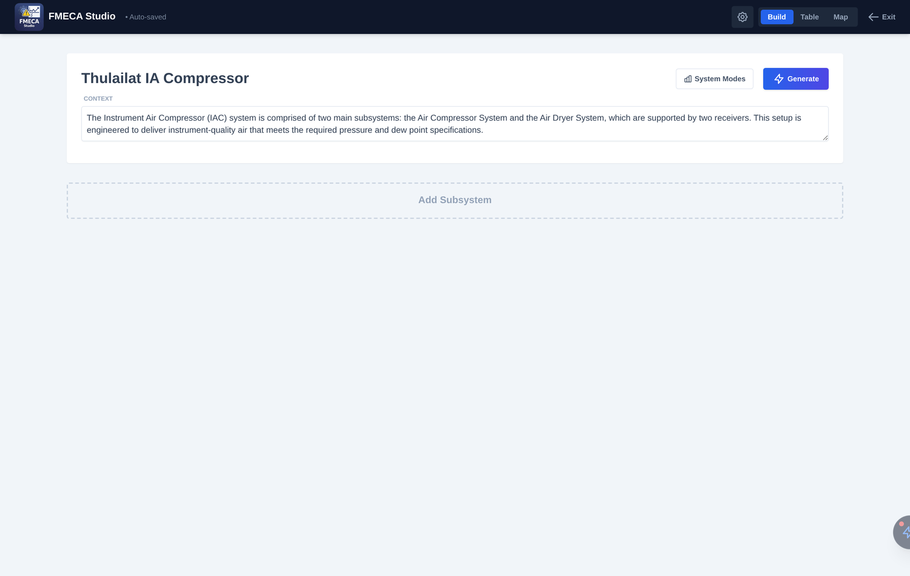
Figure 4.2 — On an empty project the master “Generate” button (top-right) is active and builds the whole FMECA from the project context.
“Generate” works only on an empty FMECA
The master Generate button is available only while the project has no subsystems yet — it is greyed out (“Available only when the FMECA is empty”) once content exists, so it can never overwrite your work. To regenerate from scratch, delete the subsystems first. To add to an existing analysis, use Auto-Fill and Generate Modes instead.

“Auto-Fill” — draft one subsystem
Once a subsystem has a name, specs and a function, click Auto-Fill (the wand button next to the Function field) to generate that subsystem’s complete failure analysis — its functional failures and, under each, the failure modes with their effects, causes and mitigations (both the current-controls context and the suggested mitigation actions). Use this to fill out subsystems one at a time, or to add analysis to a subsystem you created manually.

“Generate Modes” — draft the rows under one failure
On any functional failure, click the Generate Modes link (the lightning icon). The AI proposes several credible failure-mode rows for that specific failure, each already populated with the mode, effect, cause and mitigation. This is the right tool when you have written the functional failures yourself and only want the modes drafted.

The magic wand — one field at a time
Every text field (Function, Specs, functional-failure description, mode, effect, cause, mitigation) carries a small magic-wand icon that appears on hover. It is context-aware and behaves according to how much text is already there:
- Empty field — writes appropriate content from scratch, using the project and subsystem context.
- Short text (a few words) — corrects spelling and grammar only, leaving your wording intact.
- Longer text — enhances and expands what you have already written, keeping your meaning.
Recommended generation workflow
New asset: click Generate for a full first draft → review.
Adding to it: use Auto-Fill per subsystem or Generate Modes per failure.
Polishing: use the magic wand on individual fields. Then score RPN (Section 4.7). Always review AI output against plant history.

4.3 Add subsystems, specifications and function
If you prefer to build manually (or need to add to a generated draft), use Add Subsystem to create each maintainable sub-assembly, then fill three fields:
- Subsystem name — e.g. “Screw Compressor”.
- Specs — the nameplate / design data (type, capacity, pressure, motor rating, configuration). The example lists “Oil-Flooded Rotary Screw, 600 SCFM, 10 barg, 110 kW, 2980 rpm, 1 Active + 1 Standby”.
- Function — a full statement of what the subsystem must do and to what standard. Write this carefully; it is the anchor for the whole failure analysis below it.
You do not have to write everything by hand. The Auto-Fill button (beside the Function field) asks the AI to draft the function from the subsystem name and specs, and the small magic-wand icon inside any text field will generate text from scratch when the field is empty, fix grammar on short text, or enhance longer text you have already written.

4.4 Decompose the function (Function Breakdown)
A single function statement usually bundles several distinct performance requirements. Click the ⊞ icon next to the FUNCTION label to open the Function Breakdown tool. It splits the function into discrete function / expectation pairs and lets you verify that each one is covered by a functional failure — the backbone of RCM traceability.
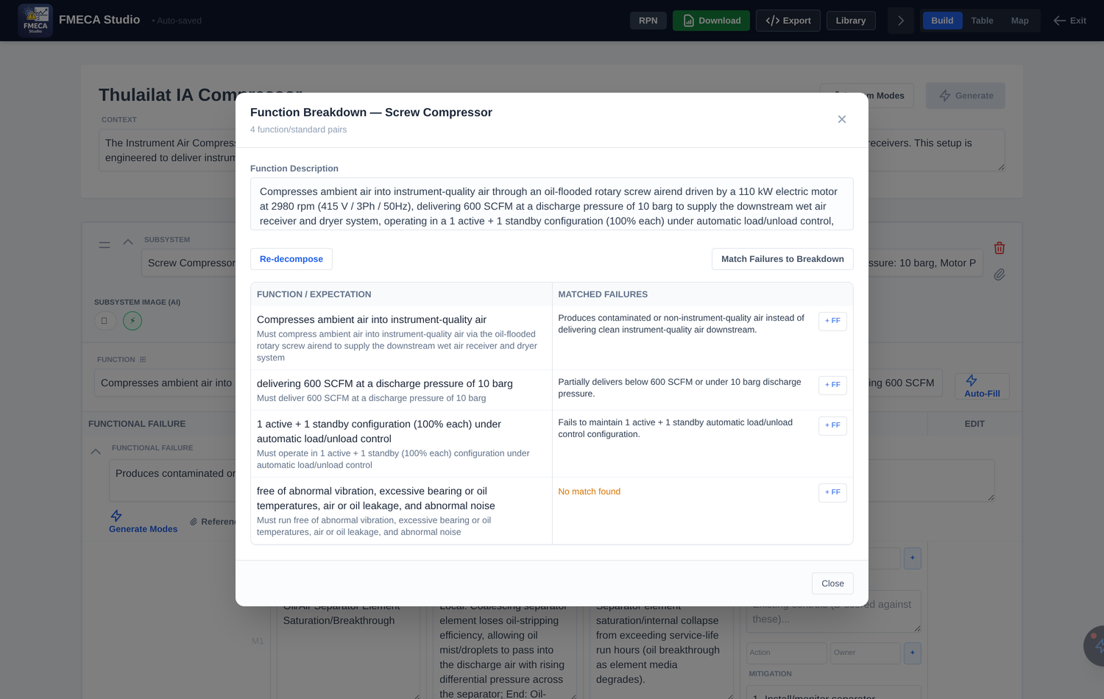
Figure 4.3 — Function Breakdown: each performance standard is matched to a functional failure. “No match found” flags a gap.
Use Re-decompose to regenerate the breakdown after editing the function, and Match Failures to Breakdown to auto-link existing functional failures to each standard. Where the tool shows “No match found” (as for the abnormal-vibration standard in the example), you have identified a missing functional failure — click + FF to create it. This is a powerful completeness check before you sign off an analysis.

4.5 Add functional failures
Under each subsystem, use + Add Failure to record each way the function can fail, phrased as a loss of function (e.g. “Produces contaminated or non-instrument-quality air instead of delivering clean instrument-quality air downstream”). Keep functional failures at the level of the performance standard, not the mechanism — mechanisms belong in the failure modes below.

4.6 Add failure modes, effects, causes and controls
For each functional failure, add the specific failure modes that cause it. Each mode row captures four analytical fields plus mitigation:
- Failure Mode — the mechanism (e.g. “Oil/Air separator element saturation / breakthrough”).
- Failure Effect — written as Local and End effects (e.g. separator loses efficiency → oil-laden air reaches the dryer and instruments).
- Failure Cause — the underlying reason (e.g. element service-life exceeded).
- Current Controls — barriers already in place; the Detection score is judged against these.
- Mitigation — recommended actions. The Mitigation builder lets you enter each action with an Owner and auto-numbers the list, so tasks read as “1- … (Mechanical team); 2- … (Instrument team)”.
The Generate Modes link (the lightning icon on a functional failure) asks the AI to propose a set of credible modes with their effects, causes and mitigations, which you then review and edit. Treat AI output as a first draft to be checked against your plant history — never as the final word.

4.7 Score the risk (RPN)
FMECA Studio uses the standard Risk Priority Number: RPN = Severity × Occurrence × Detection, each rated on a 1–10 scale. Enter the three numbers in the S / O / D boxes on each mode row, or click the AI-score (robot) button on the row to have the AI propose a defensible S/O/D based on the effect, cause and current controls. The computed RPN is colour-coded so the worst risks stand out at a glance:

RPN band | Colour in the app | Interpretation
RPN ≥ 100 | Red | High priority — act first; strengthen detection / prevention
40 – 99 | Yellow | Medium — plan mitigation
Below 40 | Green | Low — monitor
Blank / Unscored | Grey | Not yet assessed

Baseline vs. mitigated RPN
The AI scorer can record a baseline RPN (using only the current controls) alongside the mitigated RPN (after the recommended actions), so you can demonstrate the risk reduction your maintenance strategy delivers. Turn the RPN column on or off with the RPN toggle in the toolbar.

5. AI-assisted features
Beyond the per-field wand and the Generate buttons, two features help you bring real operating knowledge and a reference library into the analysis.

5.1 System Modes — injecting operational failure data
The System Modes button (top-right of the editor) lets you upload real failure history — an Excel sheet with two columns, Failure Mode and Failure Count (occurrences). FMECA Studio ranks this data and injects it as context into every AI prompt, so generated modes reflect what actually fails on your equipment rather than generic textbook modes.
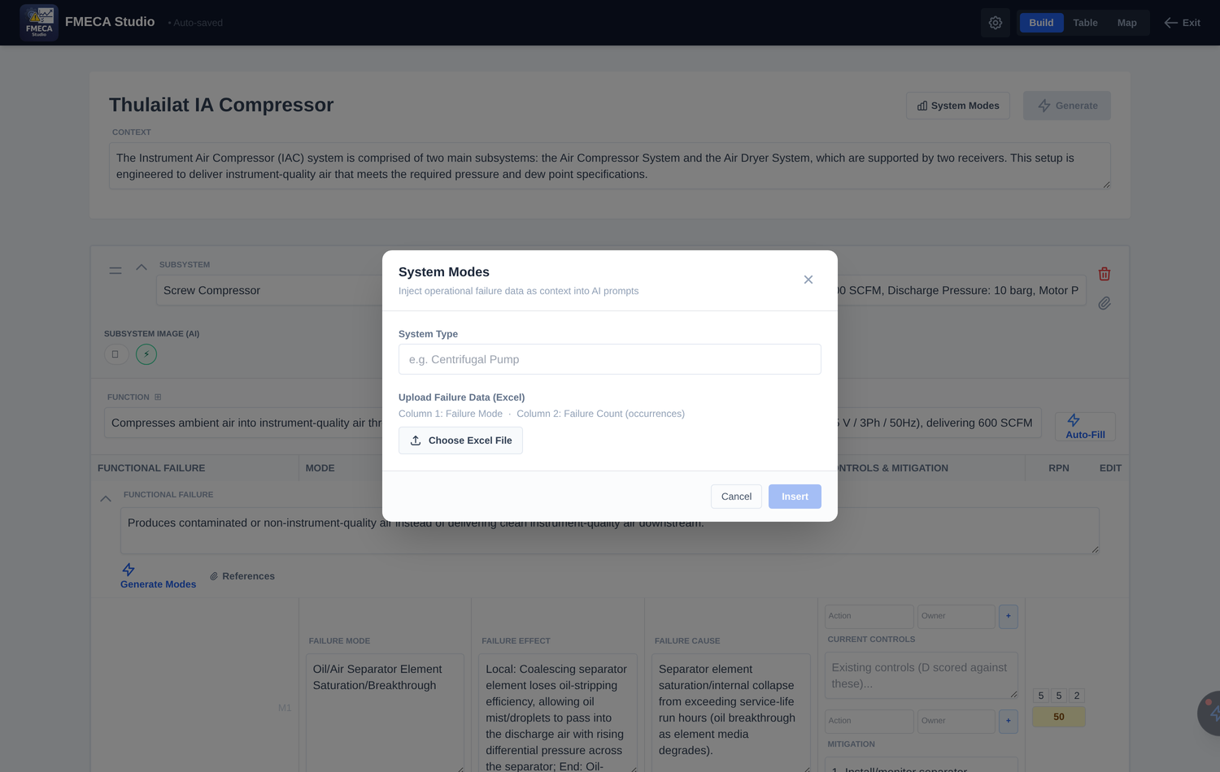
Figure 5.1 — System Modes: upload ranked operational failure counts to ground the AI in real plant history.

5.2 The failure library
The Library panel (open the toolbar, then click Library) holds reusable failure records grouped by equipment class — for example Centrifugal Pumps and Electric Motors — each with a Mode, Effect, Cause and suggested Task. Use it as a starting palette for common equipment, and load your own library with the upload icon (download the template first with “Get Template”).
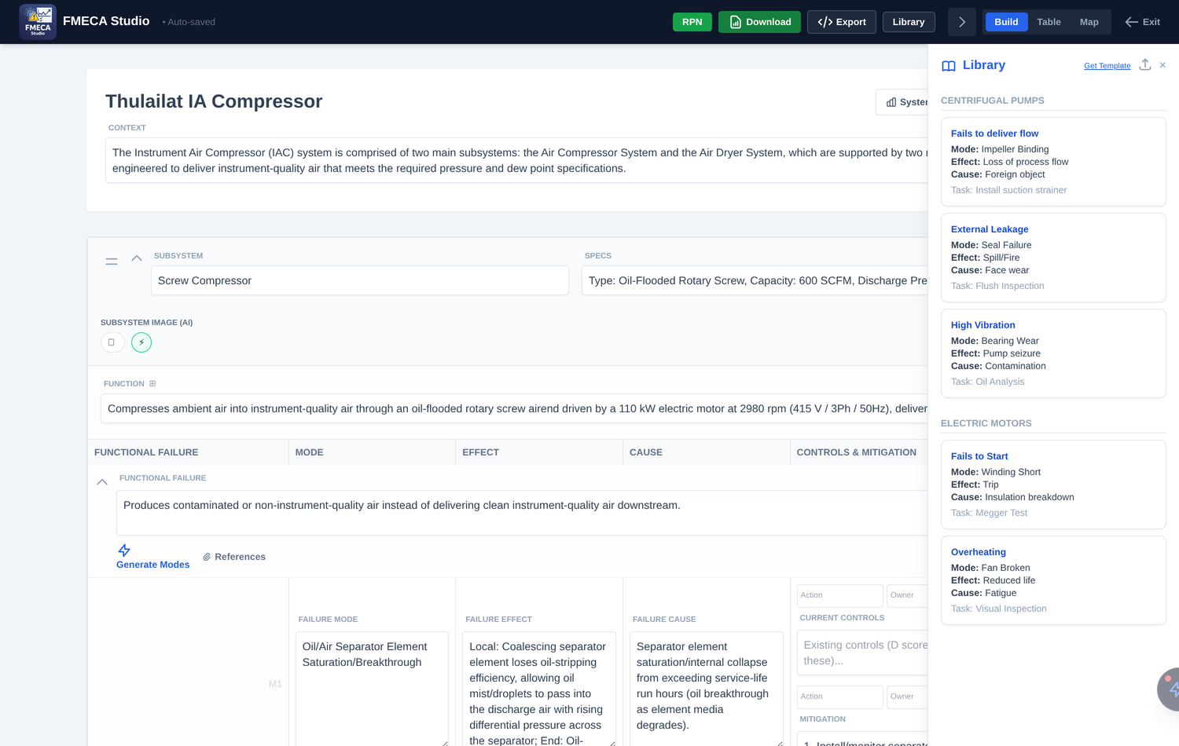
Figure 5.2 — The failure library, grouped by equipment type.

5.3 The FMECA Copilot chatbot
The floating FMECA Consultant (the wand tab on the right edge of the editor) is a senior-reliability-engineer chat assistant. With RAG ON it retrieves exact data from your open project — subsystems, failure modes and RPN summaries — before answering, so you can ask questions such as “Which modes have the highest RPN?” or “Suggest additional detection for the oil-carryover mode.” The green “Project Context Active” badge confirms it is reading your live data.
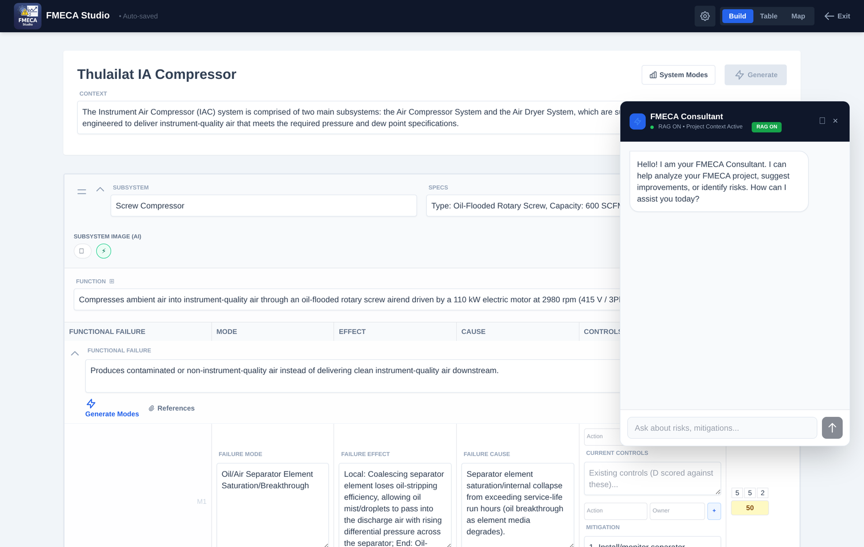
Figure 5.3 — The FMECA Consultant chatbot with retrieval (RAG) over the open project.

6. Views and the toolbar
The editor offers three views of the same data, switched from the Build / Table / Map buttons in the header. The toolbar (the gear/arrow button) reveals the RPN toggle and the export buttons.
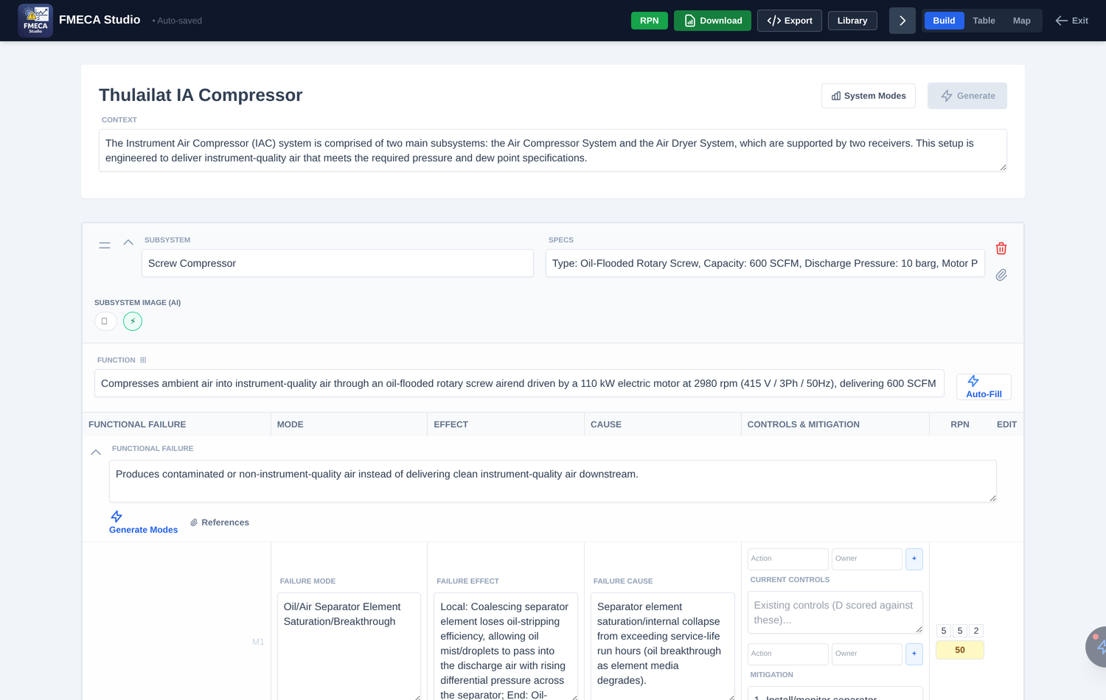
Figure 6.1 — The expanded toolbar: RPN toggle, Excel Download, JSON Export and Library.

6.1 Table view
The Table view renders the analysis as a classic spreadsheet-style FMECA worksheet, with subsystem and functional-failure cells merged across their modes and the S / O / D / RPN columns on the right. This is the review-and-sign-off view and the layout that matches the exported Excel file.
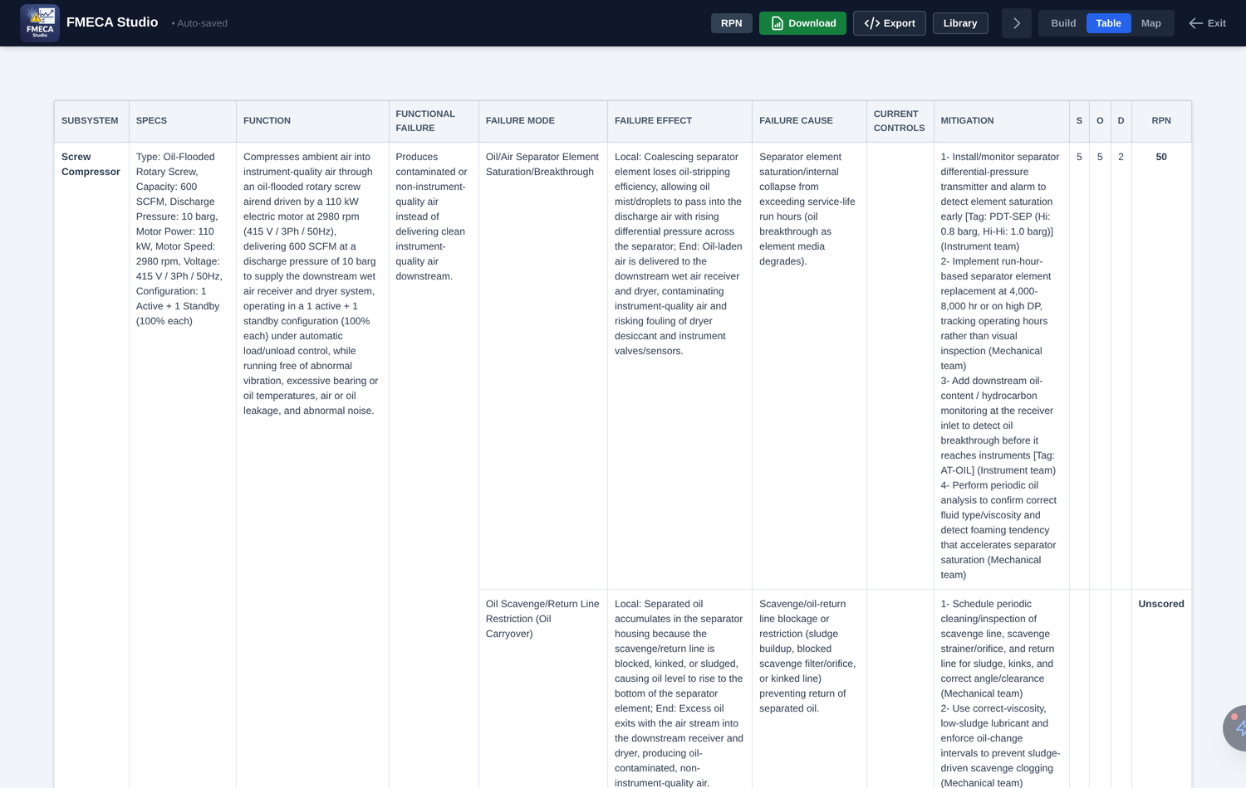
Figure 6.2 — Table view: the structured FMECA worksheet with merged cells and RPN.

6.2 Map view
The Map view draws the analysis as a top-down tree — project → subsystems → functional failures → modes. Use Expand / Collapse, the zoom control and the level selector (Subsystems / deeper levels) to focus the diagram.
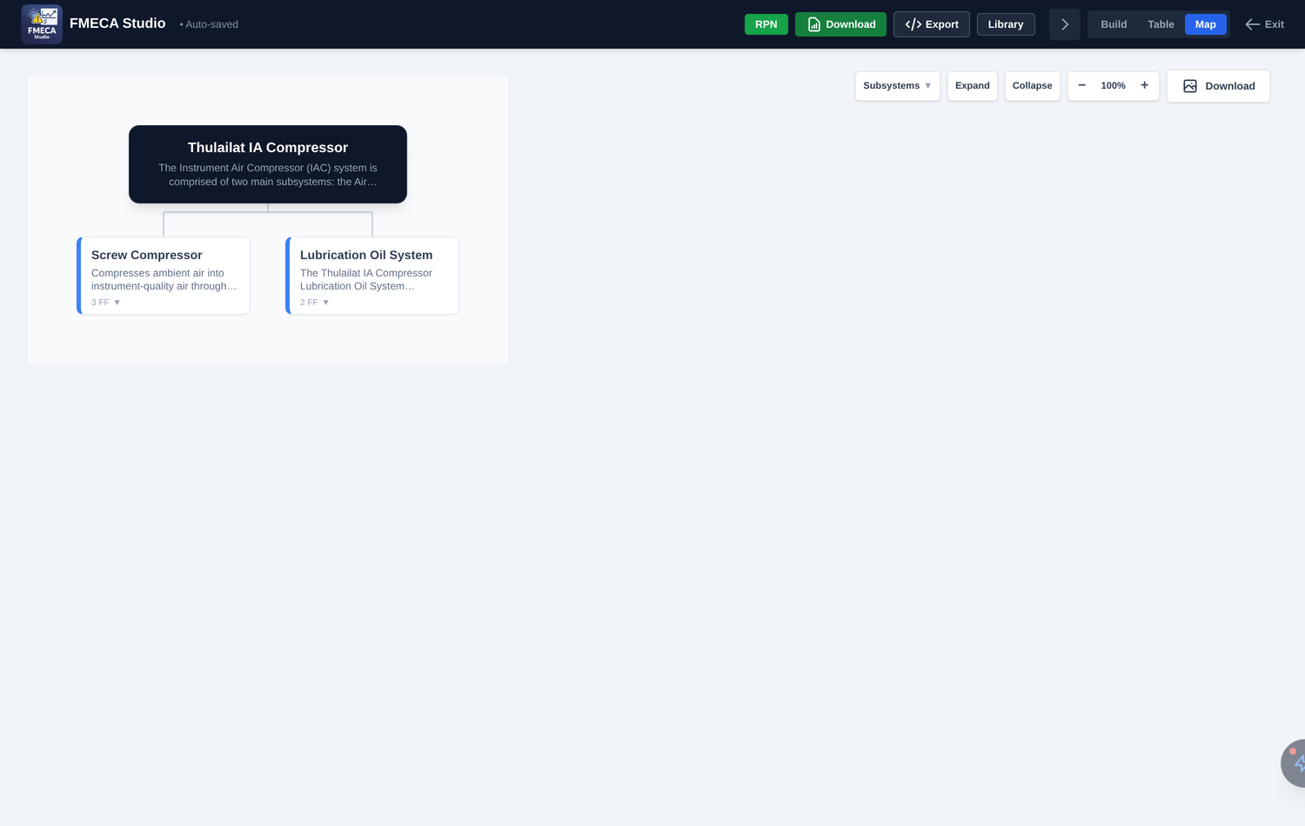
Figure 6.3 — Map view: a navigable tree of the asset breakdown.

Downloading the map
Click the Download button (top-right of the Map) to open a menu with four export formats. Choose the one that suits the destination:
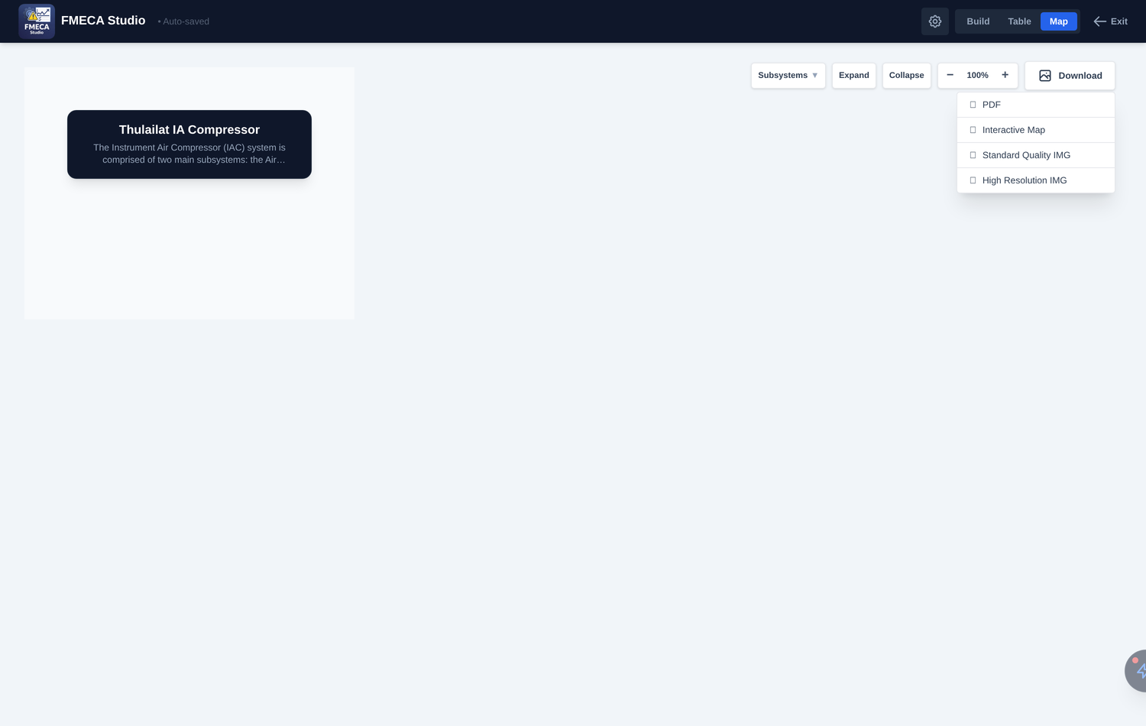
Figure 6.4 — The Map Download menu offers PDF, an interactive HTML map, and two PNG resolutions.
Menu option | File type | Best for
PDF | PDF | A print-ready page of the map for reports, sign-off packs and archiving
Interactive Map | HTML | A self-contained web page you can open in a browser and pan / expand — ideal for sharing a clickable map by email
Standard Quality IMG | PNG | A quick, screen-resolution image for slides and documents
High Resolution IMG | PNG | A high-resolution (4×) image for large-format printing or zooming in

Tip
The PDF and HTML exports capture the map exactly as it is currently expanded and zoomed, so set the level selector and Expand / Collapse the way you want before exporting.

7. Exporting and sharing
FMECA Studio produces several export formats from the toolbar and the Map view:
Format | Where | Use it for
Excel (.xlsx) | Download (toolbar) | The formatted FMECA worksheet with merged cells — the main deliverable for review and archiving
JSON | Export (toolbar) | A complete backup of the project; re-import it on any machine or share with a colleague
PDF | Download menu (Map view) | A print-ready page of the asset-breakdown tree
HTML (Interactive Map) | Download menu (Map view) | A shareable, browser-openable interactive map
PNG (Standard / High-Res) | Download menu (Map view) | The tree diagram as an image for slides, documents and printing

Back up regularly
Because projects live in your browser’s local storage, export a JSON file at the end of every working session and store it with your project records. This is your only backup if the browser data is cleared.

8. Best practice for a professional FMECA
The tool accelerates the work, but a defensible FMECA still depends on engineering discipline. The following practices produce a worksheet that will stand up to audit.
- Write functions to a measurable standard. “Deliver 600 SCFM at 10 barg” is auditable; “supply air” is not. Strong function statements make every failure below them sharper.
- Close every gap in the Function Breakdown. Treat each “No match found” as an action to add a functional failure before sign-off.
- Ground the AI in real data. Load operating history through System Modes and a PM checklist through Checklist Knowledge so mitigations reflect your plant, not a generic template.
- Always review AI output. Generated modes, effects and RPN scores are drafts. Confirm them against plant history and your own judgement — you remain the author of record.
- Score detection against real controls. Fill Current Controls before scoring D, and use the baseline-vs-mitigated RPN to show the value of your recommendations.
- Name an owner for every action. The Mitigation builder’s Owner field turns recommendations into assignable tasks.
- Export a JSON backup and an Excel deliverable at each milestone. Version them with the analysis date.

Quick-reference: end-to-end workflow
- Import or create a project and write a clear Context.
- Add each subsystem with its specs and function (use Auto-Fill to draft).
- Run Function Breakdown and close any unmatched standards.
- Add functional failures, then generate and refine failure modes.
- Complete effects, causes, current controls and mitigations (with owners).
- Score S/O/D (manually or with the robot); review the coloured RPNs.
- Check the Table view; ask the Copilot to sanity-check the highest risks.
- Export Excel for the deliverable and JSON for backup.

— End of guide —

